Project Report file on
STUDENTSYNC
Submitted in the partial fulfillment of the requirement for the award of degree of
Bachelor of Technology
Computer Science and Engineering
Batch (2022-2026)

Submitted to: Submitted by:
Ms. Bindu Simran Kaur
Assistant Professor 12200683
DEPARTMENT OF COMPUTER SCIENCE AND ENGINEERING
DAV UNIVERSITY
JALANDHAR - PUNJAB (144303)

ABSTRACT
In today’s fast-paced campus life, managing resources, posts, and student listings efficiently is essential. StudentSync is designed to simplify the way students buy, sell, and share items on campus. The platform provides a secure, organized, and easy-to-use system where students can list items, manage their posts, and find what they need quickly.
Key features of StudentSync include:
- Secure Listings: Ensuring all posts and user data are protected for a safe trading environment.
- Organizational Tools: Allowing students to categorize items into different sections or tags for easy browsing.
- Smart Search: Advanced search functionality to quickly find items by name, category, or tag.
- User Management: Enabling students to manage their profiles and control visibility of their listings.
- Post History & Updates: Keeping track of item listing changes and allowing easy edits or updates.
- Activity Logs: Recording user actions to maintain transparency and trust within the campus community.
StudentSync is designed to be scalable and adaptable to the needs of any campus. By centralizing buying, selling, and sharing into one platform, it aims to improve student convenience, encourage community participation, and make campus life more connected and efficient.

ACKNOWLEDGEMENT
I would like to express my sincere gratitude to my project guide, Ms. Bindu, for their valuable guidance, constructive feedback, and continuous support throughout the duration of this project. I am also thankful to Rahul hans and the Department of Computer science and engineering for providing the necessary resources and an encouraging academic environment.

My appreciation extends to all faculty members and classmates whose suggestions and cooperation helped strengthen the quality of this work. Lastly, I am deeply grateful to my family for their constant encouragement and support, which motivated me to complete this project successfully.

SIMRAN KAUR

INDEX

SR. NO. | CONTENTS | PAGE NO.
1. | Introduction to project | 1-3
2. | Existing system | 4-5
3. | Proposed system | 6-10
4. | Feasibility system | 11-13
5. | System requirement specification(SRS) | 14-17
6. | Data flow diagram(DFD) | 18-20
7. | Technology used | 21-26
8. | Screenshots | 27-30
9. | System Testing | 31-33
10. | Conclusion and Future Work | 34-35
11. | Bibliography | 36

CHAPTER-1
INTRODUCTION
In today’s fast-moving campus environment, students often struggle to find essential resources quickly—whether it’s academic materials, hostel necessities, or pre-owned items. With scattered information, unorganized seller–buyer networks, and inefficient communication methods, accessing needed items can be time-consuming and frustrating. StudentSync emerges as an innovative digital platform designed to streamline student-to-student exchange by connecting buyers, sellers, and campus communities efficiently. It aims to simplify campus life by offering a fast, transparent, and accessible solution for buying, selling, or exchanging items within the university ecosystem.

Key Features

• Easy Buyer–Seller Connectivity
Campus Connect Market connects students through a centralized marketplace, enabling quick communication and smooth exchanges within the campus.

• Real-Time Listings & Availability
Students can browse updated listings, check item availability instantly, and find relevant deals without delays.

• Convenient Posting & Request Handling
Users can easily post items for sale, request specific items, chat with sellers, negotiate prices, and track interactions using a clean, user-friendly interface.

• Verified Student Profiles
All users are verified through university details, ensuring trust and safety for every transaction on the platform.

• Time-Saving Digital Marketplace
Replaces traditional word-of-mouth or offline notice boards with an automated platform that drastically cuts down search time for both buyers and sellers.

• Accessible for All Campus Members
Designed for students, hostellers, club members, faculty, and campus vendors—promoting a broad, connected, and resource-rich community.

• Encouraging Reuse & Sustainable Practices
Campus Connect Market motivates students to recycle and reuse goods, reducing waste while promoting a culture of affordability and sustainability on campus.

1.1 PROBLEM DEFINITION
StudentSync is a modern campus marketplace platform designed to solve the growing need for accessible, reliable, and organized student-to-student exchange within universities. The system aims to provide an efficient and dependable solution by connecting buyers and sellers through real-time information sharing.
In a university environment where students frequently need academic materials, daily essentials, and pre-owned products, finding the right item at the right time becomes a significant challenge. Campus Connect Market simplifies this entire process by offering instant access to item availability, seamless request handling, and transparent communication. It addresses the increasing demand for fast, trustworthy, and digital solutions within the campus community.
The problems that students commonly face while searching for items on campus are as follows:

● Unorganized Seller Information
Traditional methods rely on WhatsApp groups, notice boards, or word-of-mouth communication, making it difficult for students to find reliable sellers or available items quickly.

● Time Sensitivity
Students often need materials urgently—such as textbooks before exams or essentials after shifting hostels—yet existing informal methods are slow, scattered, and inefficient.

● Limited Access
Students struggle to get in touch with sellers due to the absence of a centralized marketplace and proper communication channels within the campus.

● Verification Issues
Without proper verification, it becomes challenging to ensure the authenticity of sellers or the condition of items, leading to distrust and confusion.

● User Expectations
Modern students expect fast, transparent, and technology-driven solutions that simplify buying/selling and reduce unnecessary effort.

CHAPTER 2
EXISTING SYSTEM
The current landscape of campus buying and selling relies heavily on traditional, informal, and unorganized methods. Most students depend on WhatsApp groups, word-of-mouth communication, classroom announcements, physical notice boards, or social media posts to find items or connect with a seller. These outdated methods often result in delays, miscommunication, and inconvenience for students who need items urgently.
Such issues cause frustration and inefficiency among students looking for academic materials, hostel essentials, event supplies, or pre-owned goods. With growing digital expectations, students increasingly demand a dependable, organized, and real-time marketplace that allows quick access to available items without unnecessary struggle.
Some of the major problems in the existing system are defined below:

● Manual Searching
Students still rely on manually asking friends or checking multiple groups to find sellers or items, which becomes time-consuming and often unsuccessful.

● Unverified Information
Details shared through informal groups may be outdated, unreliable, or exaggerated, leading to misunderstandings or distrust between buyers and sellers.

● Lack of Centralization
Information is scattered across various WhatsApp groups, social media pages, and college networks, making it difficult to track genuine listings efficiently.

● Delayed Responses
Slow communication, missed messages, and inactive sellers result in unnecessary delays, especially when items are needed urgently.

To overcome these issues, we propose an interactive web-based application that provides a modern, reliable, and organized campus marketplace system.
The purpose of StudentSync is to offer a platform that manages product listings, user verification, requests, communication, and notifications — all in one place — enabling students to buy and sell items effortlessly and efficiently.

CHAPTER 3
PROPOSED SYSTEM
StudentSync is an advanced campus marketplace platform designed to meet the everyday needs of students by simplifying buying, selling, and exchanging items within the university environment. It aims to eliminate delays by providing real-time product availability, an organized listing system, and seamless connectivity between buyers, sellers, and administrators. The system promotes transparency, improves communication, and ensures a fast, reliable, and user-friendly marketplace experience for all campus members.

Advantages of Using StudentSync

● Convenience
The platform enables easy posting of items, instant visibility of listings, quick searches, and real-time notifications — ensuring fast and efficient interactions between buyers and sellers.

● Authenticity
Unlike informal groups and social media pages, Campus Connect Market maintains verified student profiles, ensuring trustworthy and safe campus-level transactions.

● Centralized Information
All product listings, user details, availability statuses, and item requests are stored in a single unified platform, making it easier for users to access required information immediately.

● Time-Saving Efficiency
By providing instant access to available items and direct connectivity with sellers, the platform reduces search time and enhances student convenience, especially during urgent needs such as exam seasons or hostel shifting.

3.1 DETAILED ANALYSIS
StudentSync serves as a structured, reliable, and fully digitized marketplace tailored specifically for campus communities. It is designed to overcome the limitations of fragmented communication channels by offering real-time information, organized browsing, and transparent user interactions. The system supports sustainable practices, encourages student engagement, and ensures smooth transactions.
Here are some key points about the Campus Connect Market web app:

● Verified Student Profiles
The system maintains authentic and validated user information, ensuring safe and reliable transactions while building trust within the campus community.

• Real-Time Availability
Users can check up-to-date product availability, browse live listings, and request items instantly on the platform.

• Instant Notifications
Buyers and sellers receive real-time alerts for new listings, messages, offers, and item requests — reducing delays and improving response time.

• Centralized Management
All users, product listings, item requests, and marketplace activities are organized and managed within a structured, centralized system.

• User-Friendly Interface
A clean and intuitive design allows students to easily post items, explore listings, manage profiles, and track all marketplace interactions.

• Secure System
Ensures privacy, secure authentication, and safe communication between buyers and sellers through verified student accounts.
These features highlight the holistic approach of StudentSync in promoting accessibility, transparency, and efficiency while setting a new standard for campus-based marketplaces.

3.2 PROJECT MODULE
The Campus Connect Market web application is developed to provide a seamless, digitized marketplace experience for students. The platform simplifies buying and selling through an intuitive system that allows users to quickly connect with sellers, post product listings, request items, and receive updates in real time.

3.2.1 Admin Module
The admin side in the Campus Connect Market web app refers to the administrative panel responsible for managing listings, user accounts, verification processes, and overall platform monitoring.

Features of Admin Interface

● Login
Admins can securely log into their accounts to access the control panel.

● View User List
Admins can view all registered students along with their profile details.

● Manage Listings
Admins can add, update, approve, or remove product listings to ensure a safe and authentic marketplace environment.

● Monitor Requests & Reports
Admins can track item requests, user reports, complaints, and platform activities.

● Verification Control
Admins can verify student identities, approve sellers, and maintain the credibility of the system.

• Verify Listings & Requests
Admins can verify and approve product listings or item requests to maintain authenticity and prevent misuse.

• Monitor Activities
Admins can track all user interactions, listings, requests, and overall marketplace activities to ensure smooth platform operations.

3.2.2 User Module
This module allows users (students acting as buyers or sellers) to explore available items, post their own listings, and manage their marketplace activities. They can update their profiles, communicate with other users, and track the status of their posts and transactions.

Features of User Interface

● Register
Users can create new accounts using their verified student credentials.

● Login
Users can securely log in to access their personalized dashboard.

● Update Profile
Users can update their personal details, contact information, and preferences.

● View Listings
Users can browse available products based on category, price, or location within the campus.

● Create Listings
Users can post items they want to sell, including images, descriptions, and pricing.

● Track Listings & Requests
Users can monitor the status of their product listings, offers received, and responses from interested buyers.

● Transaction History
Users can view their complete buying and selling history, including previous interactions and completed transactions.

CHAPTER 4
FEASIBILITY STUDY
The process of conducting a feasibility study in software engineering involves analyzing all aspects of the project before starting its development. It includes collecting data and evaluating various components of the project based on parameters such as time, resources, technical capability, and budget constraints. After examining all factors involved in planning the project, the team determines whether the proposed system can be successfully developed within the given limitations.
Once the feasibility of the project is confirmed, the development team proceeds to plan the execution of the system by preparing detailed documentation for each development phase. This may include DFD diagrams, modelling techniques, architecture flow, and other software design frameworks necessary for building the StudentSync platform.

4.1 Need of Feasibility Study
The feasibility study is an essential stage in software project management. After conducting this study, the proposed project is either approved as feasible and continued for development or reconsidered if found impractical. The final conclusion determines whether the StudentSync system should proceed as planned, be modified, or be re-evaluated for improvements.
This study also helps identify risks associated with system development and deployment. Through proper risk analysis, the development team can anticipate challenges, explore alternative solutions, and increase the project's success rate by examining multiple parameters related to system design, implementation, and maintenance.

4.2 Types of Feasibility Study

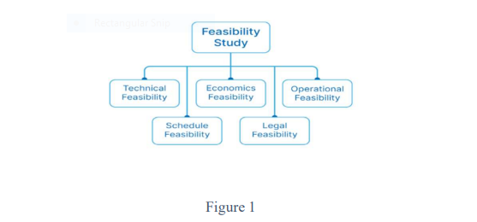

4.2 Types of Feasibility Study
To ensure that the proposed StudentSync platform can be developed successfully and function efficiently, several feasibility parameters must be evaluated. These feasibility types help determine whether the system is practical, cost-effective, and technically achievable within the given constraints.
The major types of feasibility study involved in evaluating the StudentSync system are:

1. Technical Feasibility
Technical feasibility examines whether the current technology, tools, and development resources are sufficient to build and deploy the Campus Connect Market platform. It evaluates factors such as software requirements, database management, hosting, campus network accessibility, and the development team’s technical expertise.
This ensures the system can be implemented using available and reliable technologies.

2. Economic Feasibility
Economic feasibility determines whether the project is financially viable. It includes estimating development costs, server expenses, maintenance needs, and long-term operational spending. The goal is to ensure that the cost of building Campus Connect Market is justified by its benefits, such as improved campus trading, reduced manual effort, and enhanced convenience for students.

3. Operational Feasibility
Operational feasibility evaluates whether the system will function smoothly in the real campus environment. It checks if students, sellers, administrators, and staff will effectively use the platform.
This determines whether Campus Connect Market will simplify product listings, communication, order management, and marketplace interactions without causing confusion or operational difficulties.

4. Schedule Feasibility
Schedule feasibility assesses whether the project can be completed within the given timeframe. It focuses on planning development phases, setting achievable deadlines, and ensuring the platform can be launched on time without compromising quality.
This ensures that the system can be delivered according to academic schedules and institutional requirements.

5. Legal Feasibility
Legal feasibility verifies that the platform complies with institutional rules, data privacy guidelines, and digital transaction policies. It ensures that Campus Connect Market follows regulations related to user data protection, product listings, prohibited items, and campus-approved marketplace operations.

CHAPTER 5
SYSTEM REQUIREMENT SPECIFICATION STUDENTSYNC
The Software Requirements Specification (SRS) for StudentSync defines the complete set of functional and non-functional requirements necessary for building the system. It serves as the foundation for all software engineering activities and ensures that both developers and stakeholders share a clear understanding of the project scope. The SRS is created after gathering and analysing all system requirements from students, sellers, and administrators of the platform.
This document enables users and stakeholders to verify whether the described system behaviour aligns with their expectations. It includes the user-level requirements as well as detailed system specifications required for the successful implementation of Campus Connect Market.

5.1 PROPERTIES OF A GOOD SRS DOCUMENT

• Concise
The SRS for Campus Connect Market must be clear, concise, and free from ambiguity. Unnecessary details and repetitive information should be avoided as they reduce readability and increase the chances of misunderstanding system requirements.

• Structured
The document should follow a well-defined structure for easy understanding and modification. Since Campus Connect Market may evolve over time—such as adding new features like chat improvements, payment-integration, or advanced search—the SRS must be organized to support quick revisions without confusion.

• Black-Box View
The SRS must describe what Campus Connect Market should do without specifying how it should be implemented.
It focuses on externally visible behaviour such as:
- Displaying items for sale
- Allowing students to create accounts
- Seller profile viewing
- Item search and filtering
- Chat between buyer and seller
The document should avoid internal implementation or code-level details.

• Conceptual Integrity
The document should maintain consistency and clarity throughout. A user reading the SRS should understand the entire system without confusion. Campus Connect Market should appear as a logically unified platform throughout the document.

• Response to Undesired Events
The SRS must define the system’s behaviour during exceptional or undesired scenarios, such as:
- Server failure
- Invalid login attempts
- Missing item images
- Network errors during data submission
- Unauthorized access to seller profile
It should clearly state how the system handles such cases.

• Verifiable

Each requirement stated in the SRS for StudentSync must be verifiable. That means every feature described must be able to be checked, tested, or demonstrated after implementation—for example:
- “User should be able to update their profile”
- “Search results must be displayed within 2 seconds”
- “Only logged-in users can message sellers”
These can all be verified during testing.

5.2 RESOURCES NEEDED – CAMPUS CONNECT MARKET
Resources refer to the essential system requirements and the environment within which the StudentSync platform will operate efficiently. To implement the proposed system and ensure optimal performance, the following hardware and software resources are required:

Hardware Requirements
- Processor: Intel Core i3 or above
- RAM: Minimum 8 GB
- Storage: 250 GB SSD or higher
- Display: Standard resolution (1366×768 or above)
- Network: Stable internet connection for real-time operations

Software Requirements

Front-End Technologies
- HTML
- CSS
- JavaScript
- React.js

Back-End Technologies
- Node.js
- Express.js

Database
- MongoDB (Cloud or Local)

Development Tools (Optional but recommended)
- VS Code / WebStorm
- Postman (for API testing)
- Git & GitHub (for version control)

Browser Compatibility
- Google Chrome (recommended)
- Mozilla Firefox
- Microsoft Edge
- Cross-browser responsive design support

Operating System
- Windows (Preferred)
- Linux / macOS (Supported for development)

CHAPTER 6
DATA FLOW DIAGRAM (DFD)
A Data Flow Diagram (DFD) is a graphical representation that illustrates how data moves through a system. It visually describes the flow of information, the processes that transform data, the data stores where information is held, and the external entities that interact with the system.
DFDs are widely used for analyzing both existing systems and proposed new systems, making them an effective communication tool for developers, analysts, users, and project stakeholders.
Unlike flowcharts, a DFD does not show control flow, loops, or decision-making structures. Instead, it focuses purely on data movement and data processing within the system.

6.1 SYMBOLS USED IN DFD

1. External Entity
External entities represent the actors or sources/sinks outside the system boundary.
They send data to the system or receive data from it.
Examples: Student, Seller, Admin, Payment Gateway.

2. Process
A process represents an operation that transforms incoming data into output data.
Example: Verify Login, Add Item, Process Order.

3. Data Store
Data stores represent the repositories where data is held.
Example: Users Database, Items Database, Transactions Database.

4. Data Flow
Data flows are the paths showing how data moves between processes, data stores, and external entities.
Typically represented by arrows.

6.2 PROJECT DFDs

DFD LEVEL 0 (Context Diagram)

DFD LEVEL 1 (ADMIN)
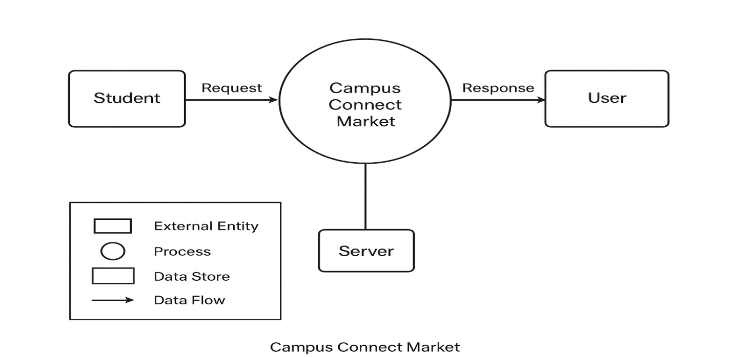

DFD LEVEL 1 (ADMIN)

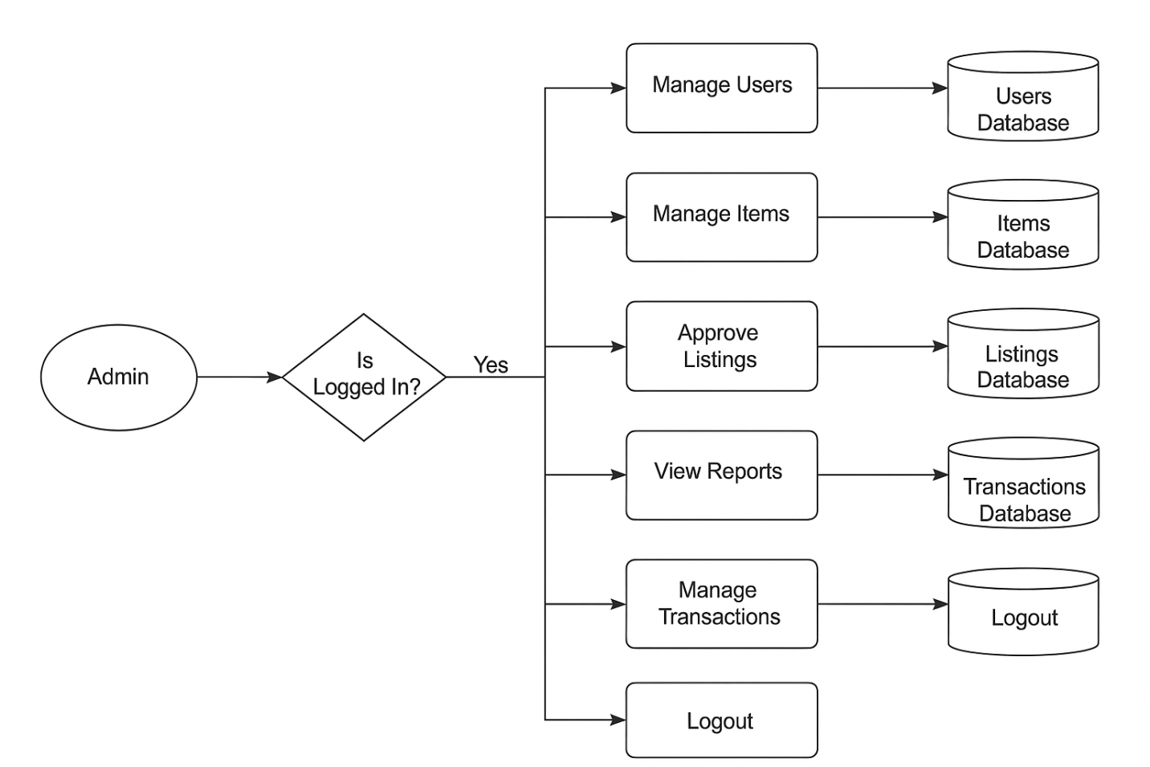

DFD LEVEL 2 (STUDENT)

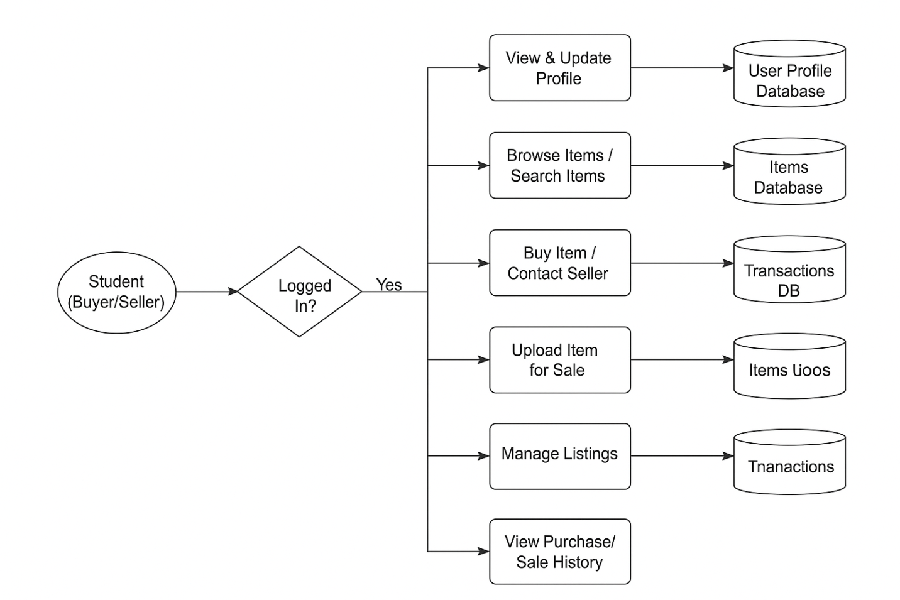

CHAPTER 7
TECHNOLOGY USED
7.1 HTML
HTML (HyperText Markup Language) is the standard language for creating webpages. It structures content on the web and is often used in conjunction with CSS (Cascading Style Sheets) and JavaScript to create visually appealing and interactive websites.


Key Feature of HTML:

• Structure and Semantics: HTML uses elements and tags to structure content, providing meaning and organization to the text, images, and other media on a webpage. • Hyperlinks: HTML allows the creation of hyperlinks, enabling users to navigate between different web pages and sections within the same page. • Media Integration: Easily embed images, audio, and video files into web pages using tags like Error! Filename not specified., , and . • Lists: Create ordered ( ) and unordered ( ) lists to organize content systematically 7.2 CSS, CSS (Cascading Style Sheets) is a stylesheet language used to describe the presentation of a document written in HTML or XML. It controls the layout, colors, fonts, and overall visual appearance of web pages.


Key Features of CSS :-
• Styling and Layout: CSS allows precise control over the layout and styling of web pages, including margins, padding, borders, and positioning of elements.
• Responsive Design: Enables the creation of responsive web designs that adapt to different screen sizes and devices using media queries.
• Animation and Transitions: CSS includes properties for creating animations and transitions, enhancing the interactivity and visual effects of web pages without JavaScript.
• Flexbox and Grid Layouts: CSS offers advanced layout modules like Flexbox and Grid, which simplify the creation of complex, flexible, and responsive grid-based designs

7.3 JAVASCRIPT
JavaScript is a versatile programming language primarily used to create dynamic and interactive effects within web browsers. It allows for client-side script execution, enabling features like form validation, content updates, and interactive interfaces without needing to reload the page.


Key Features of Javascript :-
• Interactivity: JavaScript enhances user experience by enabling interactive elements such as forms, animations, and dynamic content updates, making web pages more engaging.
• DOM Manipulation: Provides the ability to manipulate the Document Object Model (DOM) in real-time, allowing developers to update content, structure, and styles of web pages dynamically.
• Event Handling: Allows for the detection and handling of user actions like clicks, keypresses, and mouse movements, enabling responsive and interactive web applications.
• Asynchronous Programming: Supports asynchronous operations through callbacks, promises, and async/await, facilitating efficient data fetching and background processing without blocking the user interface.

7.4 React
React is a popular open-source JavaScript library for building user interfaces, particularly single-page applications where efficient data handling and rendering are essential. Developed and maintained by Facebook, React allows developers to create reusable UI components, manage the state of their applications, and render updates efficiently using a virtual DOM.



Key Features of React:
• Component-Based: React promotes building UIs using components, which are reusable and encapsulate their own logic and UI, enhancing code modularity and maintainability.
• Virtual DOM: React uses a virtual DOM to efficiently update the actual DOM, minimizing browser reflows and enhancing performance by only updating changed components. BloodLInk DAV UNIVERSITY Page | 16
• JSX: JSX is a syntax extension for JavaScript that allows writing HTML within JavaScript, facilitating the creation of declarative UI components in a familiar syntax.
• One-Way Data Binding: React enforces a unidirectional data flow, ensuring that changes in the parent component's state automatically propagate down to child components, simplifying data management and debugging.
• React Hooks: Introduced in React 16.8, hooks like useState and useEffect allow functional components to manage state and side effects, replacing class-based components and promoting cleaner and more concise code.

7.5 Node.js and Express
Node.js and Express form the backend of StudentSync, handling server-side logic, API communication, and database operations.
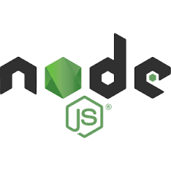
Key Features of Node.js & Express:
• RESTful APIs: Allows smooth data exchange between client and server (e.g., fetching donors, saving requests).
• High Performance: Non-blocking architecture ensures fast handling of concurrent user requests.
• Middleware Support: Provides authentication, validation, and error-handling mechanisms.
• Routing: Efficient URL routing for managing different user actions (login, register, request etc.)

7.6 MongoDB
MongoDB is the database used in StudentSync to store donor records, user details, and blood request information. Its flexible document structure makes data handling fast and efficient.
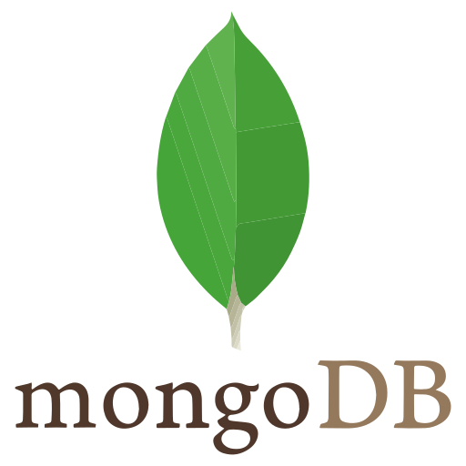
Key Features of MongoDB:
• NoSQL Document Storage: Stores data in JSON-like documents, allowing high flexibility.
• Scalability: Handles large volumes of donor and request records efficiently.
• Fast Queries: Enables quick searching of donors based on blood group, location, or availability.
• Real-Time Updates: Supports instant data updates, ensuring live donor availability.
• Data Security: Authentication and access control protect user and donor information.

CHAPTER 8
SYSTEM TESTING
8.1 Introduction of Testing
During testing the program to be tested is executed with the set of test cases and the output of the program for the test cases is evaluated to determine if the program is performing as expected. Due to its approach dynamic testing can only ascertain the presence of errors in the program, the exact nature of errors is not usually decided by testing. Testing forms is the first in determining errors in the program.
This system is tested using unit testing firstly then all the modules are integrated and again the system is tested using integrated testing and it was found that the system is working according to its expectation.
8.2 Developing a Test Plan
The first step in testing is developing a test plan based on the product requirements. The test plan is usually a formal document that ensures the product meets the following standards:
• Is thoroughly tested: Untested code adds an unknown element to the product and increases the risk of product failure
• Meets product requirements: To meet customer needs, the product must provide the features and behavior described in the product specification. For this reason, specifications should be clearly written and well understood. product
• Does not contain defects: Features must work within established quality stand and those standards should be clearly stated within the test plan.

8.3 Type of Tests

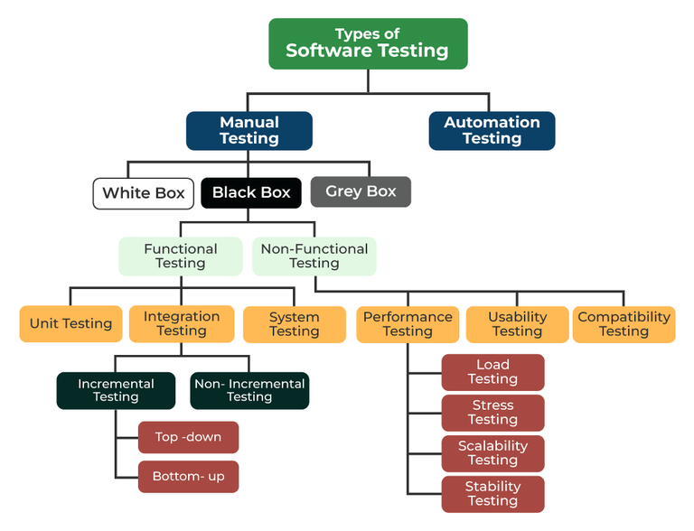

8.3.1 White Box Testing
White box testing is a software testing technique that involves testing the internal structure and workings of a software application. The tester has access to the source code and uses this knowledge to design test cases that can verify the correctness of the software at the code level.
8.3.2 Black Box Testing
Black-box testing is a type of software testing in which the tester is not concerned with the internal knowledge or implementation details of the software but rather focuses on validating the functionality based on the provided specifications or requirements.
8.3.2.1 Unit Testing
Unit testing is a method of testing individual units or components of a software application. It is typically done by developers and is used to ensure that the individual units of the software are working as intended. Unit tests are usually automated and are designed to test specific parts of the code, such as a particular function or method. Unit testing is done at the lowest level of the software development process, where individual units of code are tested in isolation.

8.3.2.2 Integration Testing
Integration testing is a method of testing how different units or components of a software application interact with each other. It is used to identify and resolve any issues that may arise when different units of the software are combined. Integration testing is typically done StudentSync DAV UNIVERSITY Page | 20 after unit testing and before functional testing and is used to verify that the different units of the software work together as intended.
8.3.2.3 System Testing
System testing is a type of software testing that evaluates the overall functionality and performance of a complete and fully integrated software solution. It tests if the system meets the specified requirements and if it is suitable for delivery to the end-users.
8.3.2.4 Performance Testing
Performance testing is a type of software testing that focuses on evaluating the performance and scalability of a system or application. The goal of performance testing is to identify bottlenecks, measure system performance under various loads and conditions, and ensure that the system can handle the expected number of users or transactions.

8.3.3 Gray Box Testing
Gray Box Testing is a software testing technique that is a combination of the Black Box Testing technique and the White Box Testing technique. In the Black Box Testing technique, the tester is unaware of the internal structure of the item being tested and in White Box Testing the internal structure is known to the tester. The internal structure is partially known in Gray Box Testing. This includes access to internal data structures and algorithms to design the test cases.

CHAPTER-9
IMPLEMENTATION OF PROJECT
• Home Page
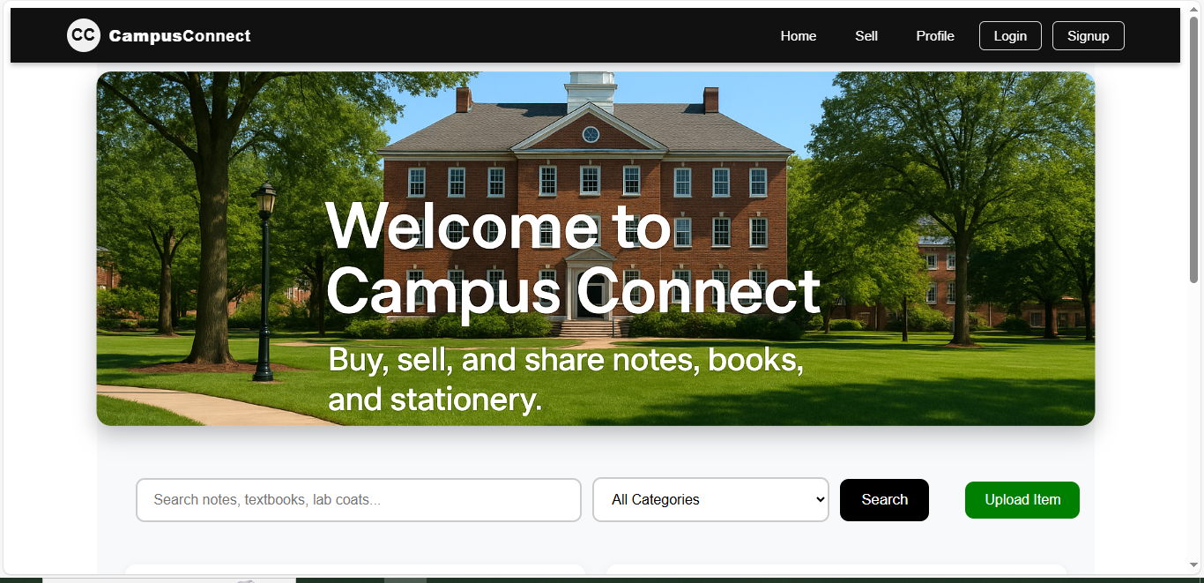

• Login
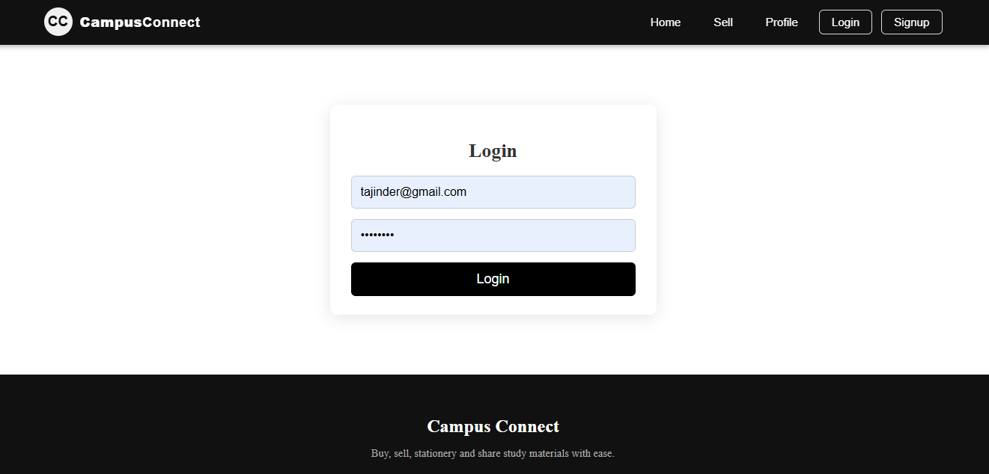

• Sign Up
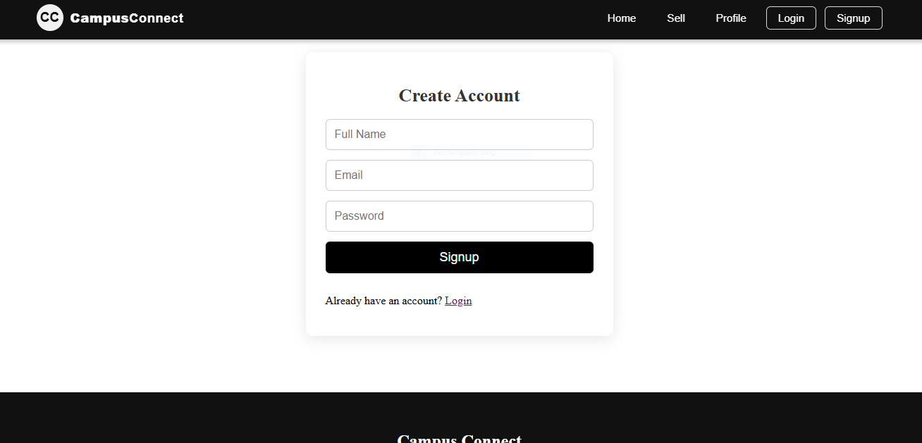

• Selling an item
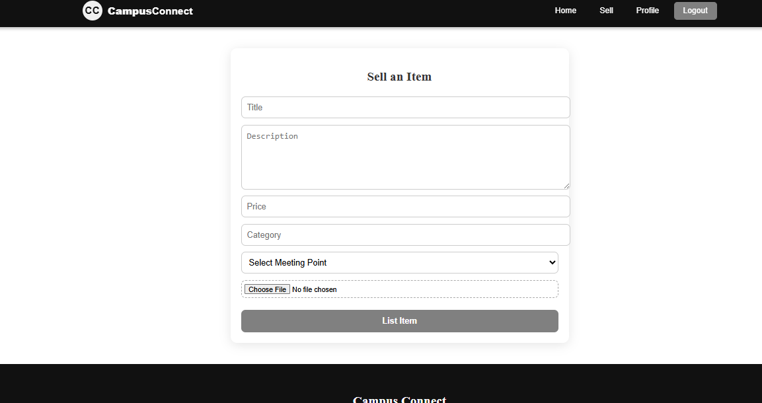

• Profile
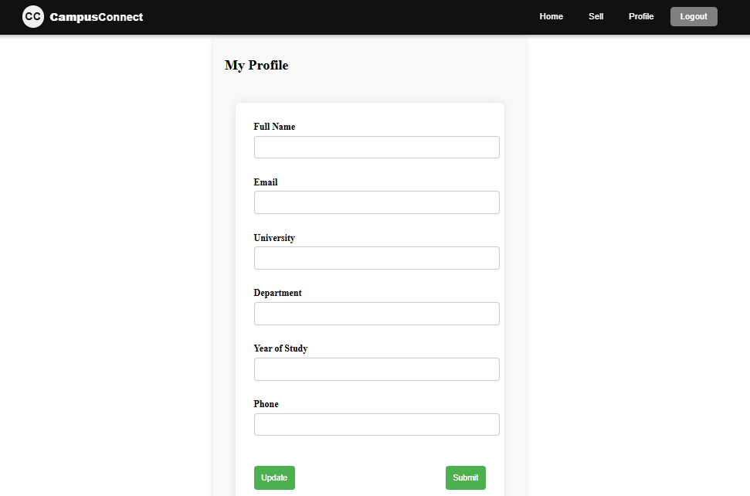

• Dashboard
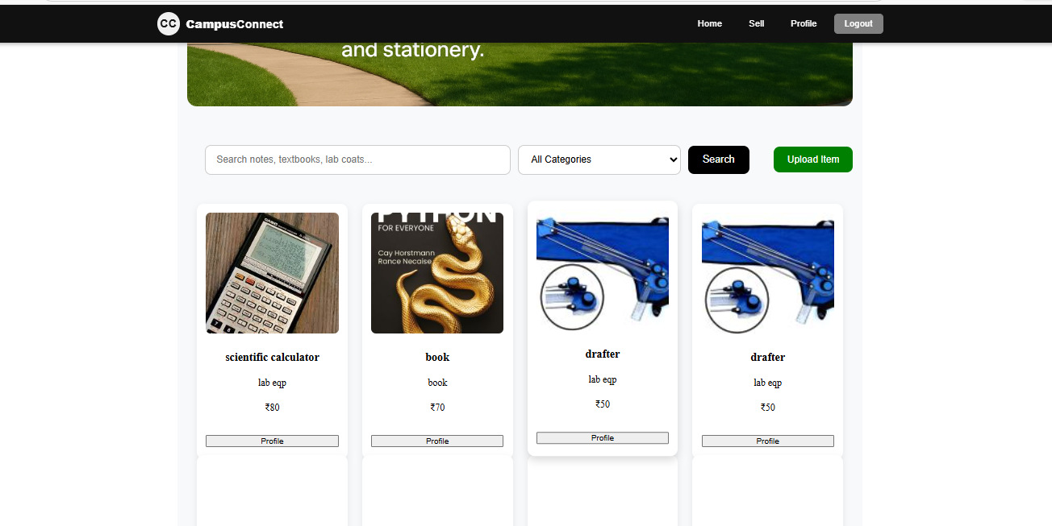

CHAPTER 10

CONCLUSION AND FUTURE WORK

10.1 CONCLUSION
StudentSync is designed to make buying, selling, and connecting on campus faster, easier, and more reliable. By providing a centralized platform for students, it bridges the gap between sellers and buyers with a smooth, transparent, and user-friendly system. Features like real-time item listings, verified profiles, instant notifications, and easy navigation ensure students save time and access what they need efficiently.
StudentSync encourages a community-driven approach where students can interact safely, share resources, and make campus life more convenient. It transforms the traditional way of campus trading into a structured digital experience that benefits both sellers and buyers equally.

10.2 FUTURE SCOPE
Some features couldn’t be implemented yet due to time constraints, but StudentSync has huge potential for expansion. Future updates aim to make the platform smarter, safer, and even more engaging. Possible improvements include:
- Automated Buyer-Seller Matching – Quickly connect students with the exact items they need.
- Live Location-Based Listings – See nearby items in real-time for faster transactions.
- Rating & Feedback System – Build trust within the campus community.
- Integration with Campus Services – Link with libraries, hostels, or events for more convenience.
- Hotspot Alerts for Popular Items – Know when trending items are available instantly.
- In-App Chat & Support – Smooth communication between buyers and sellers.
These enhancements will make StudentSync smarter, community-focused, and an essential tool for campus life in the near future.
BIBLIOGRAPHY

• To learn HTML & CSS basics: https://www.w3schools.com/
• To read documentation of JavaScript: https://developer.mozilla.org/enUS/docs/Web/JavaScript
• To read documentation of React: https://react.dev/
• To read documentation of Node.js / Express: https://nodejs.org/en/docs/
• To read documentation of MongoDB: https://www.mongodb.com/docs/
• To understand REST API concepts: https://www.restapitutorial.com/

